# SCREEN LAYOUTS

~ FRONTISPIECE ~

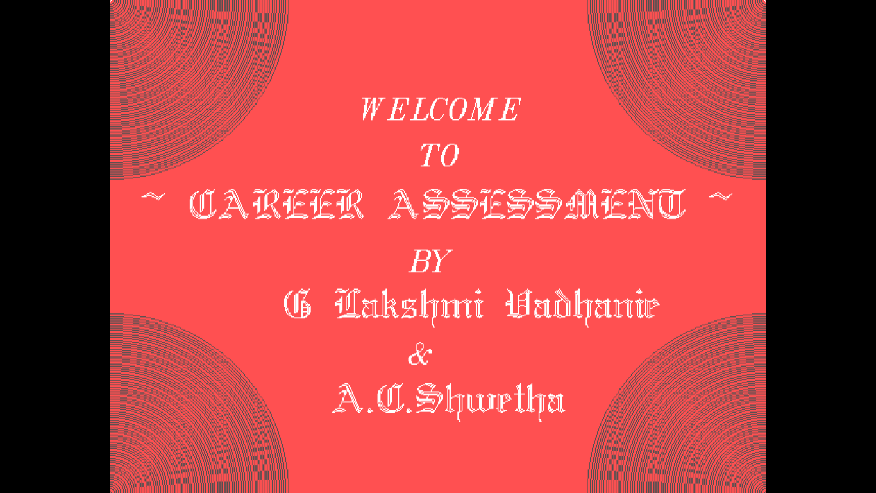

~ GUIDELINE ~

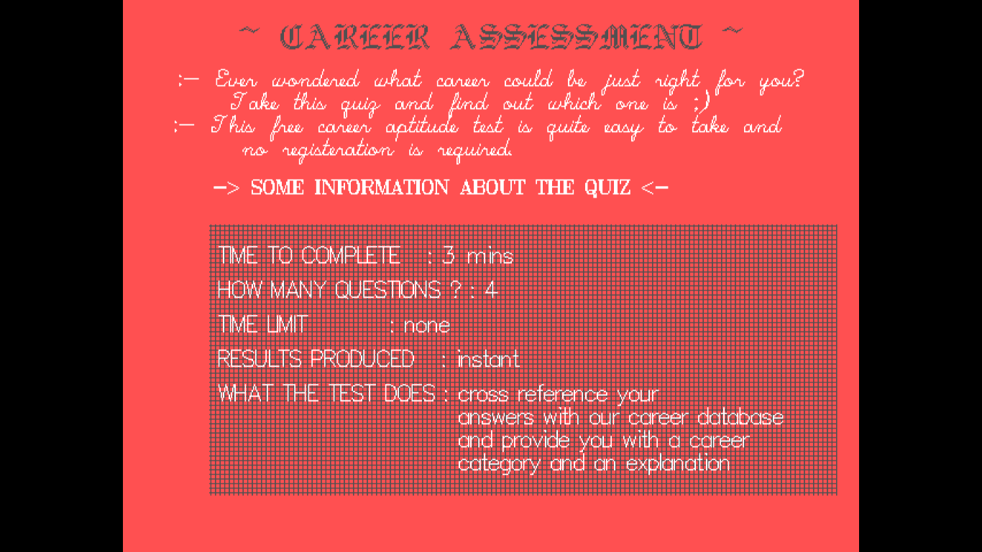

< LOADING… >

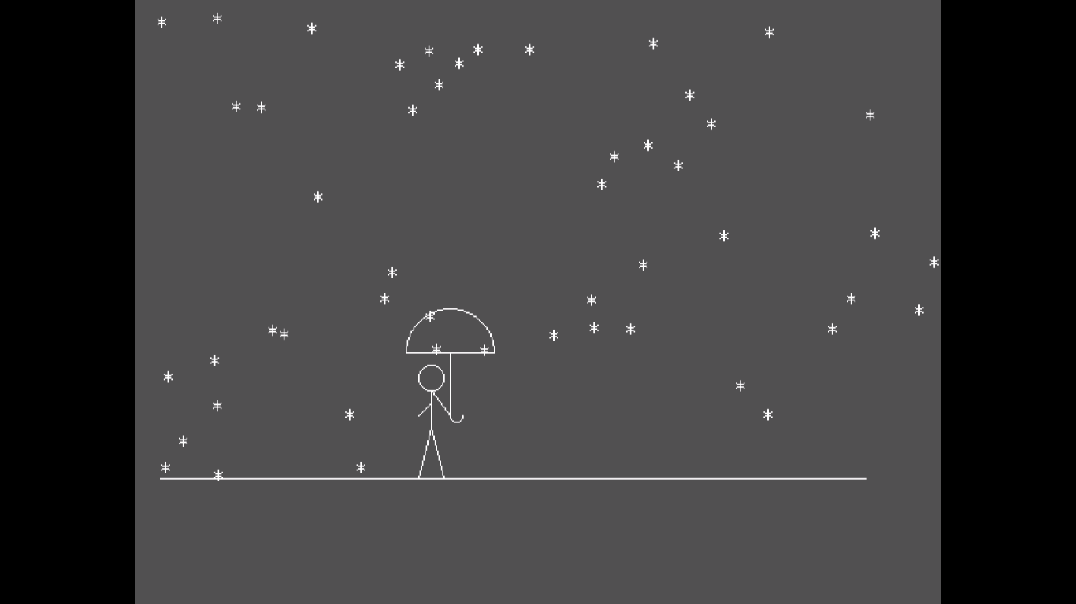

< QUESTIONNAIRE >

* *QUESTION 1*

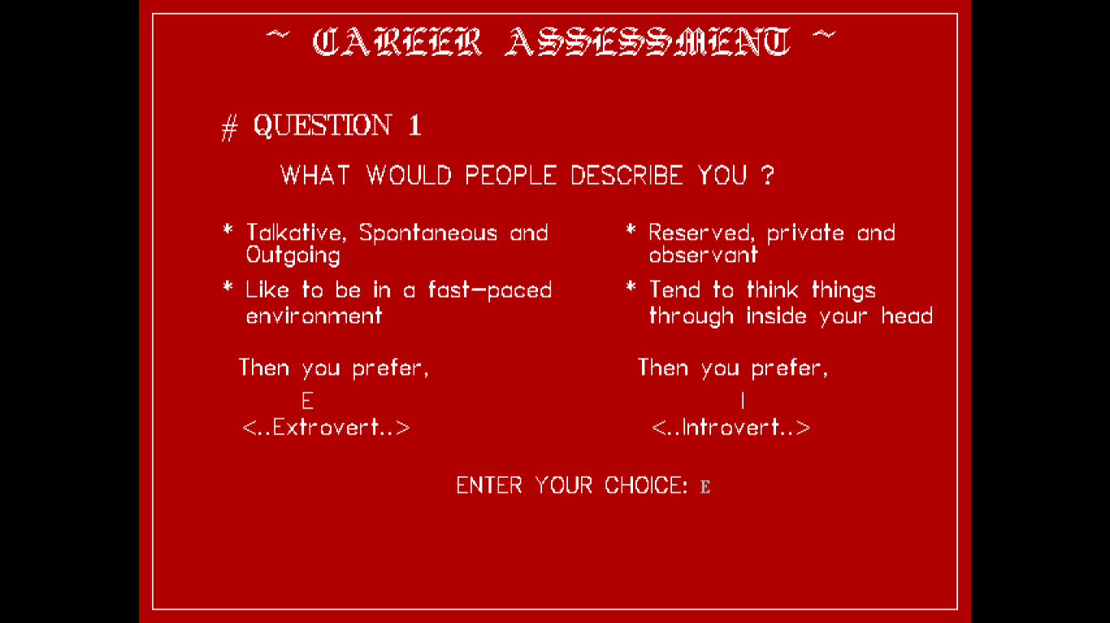

* *QUESTION 2*

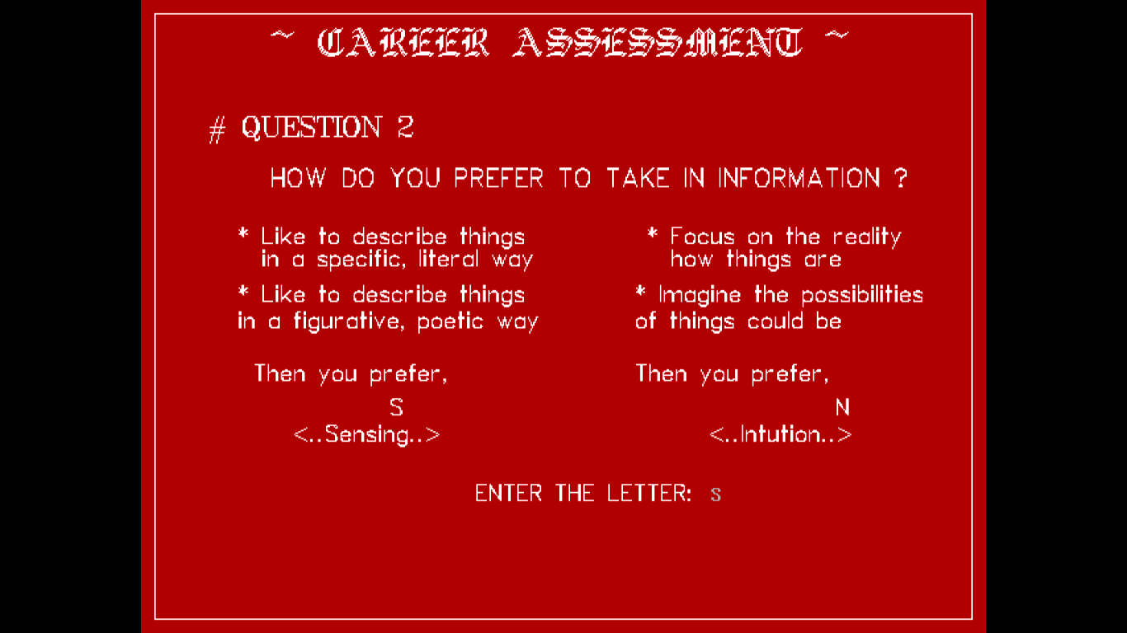

* *QUESTION 3*

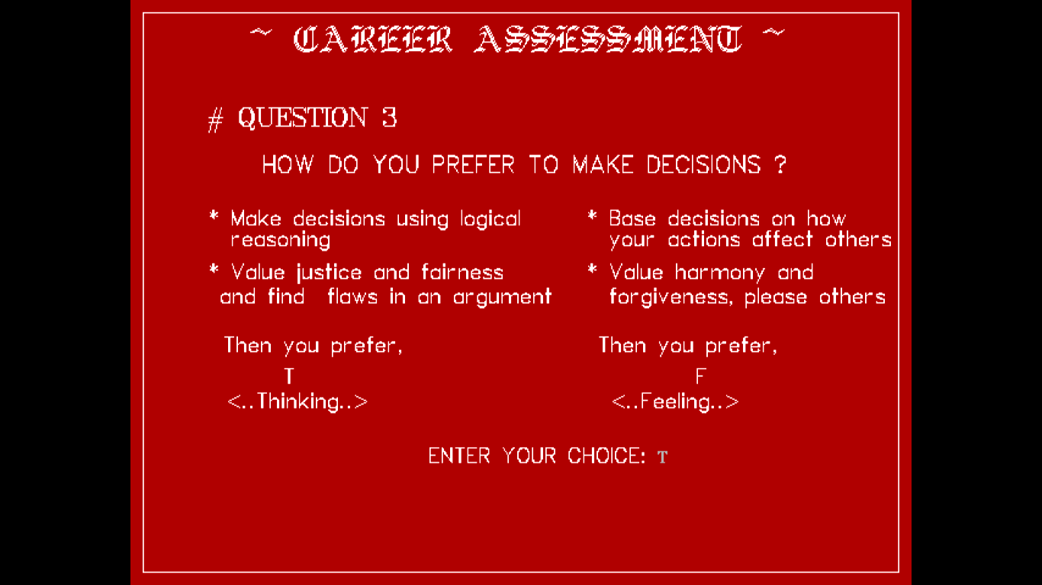

* *QUESTION 4*

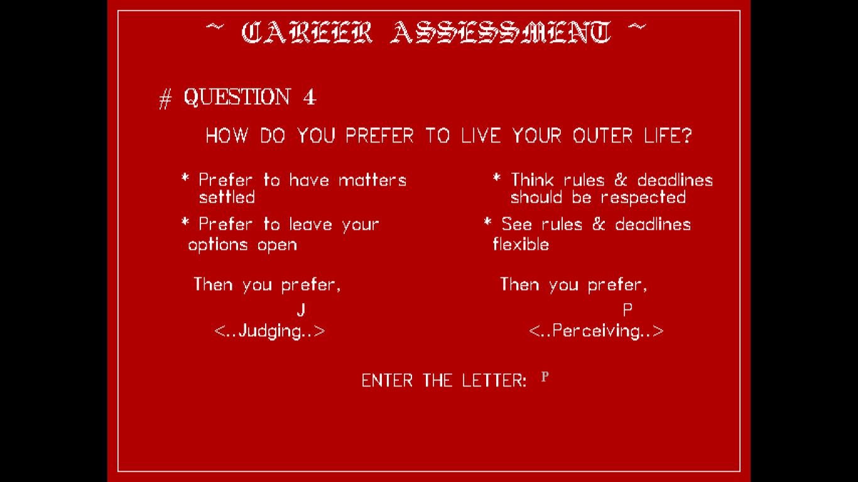

~ GOODBYE ~



# REPORT

< FOR THE ABOVE PRINTED CHOICE >



< SIMILARLY WHEN OTHER CHOICES ARE ENTERED >



< SIMILARLY WHEN OTHER CHOICES ARE ENTERED >



# CONCLUSION